Student instructions to login to a Chromebook and access Classlink
Support Assistance - Phone: 760-955-3214 Email: Helpdesk@vvuhsd.org

CONNECT YOUR CHROMEBOOK TO YOUR HOME WIFI
*** A Chromebook must be connected to a Wi-Fi network before login process can be performed ***
- In the bottom-right corner of the screen, click into the area with the Wi-Fi symbol (if it isn't enabled, you'll see an outline without an available signal inside).
- Click "Not connected" — you'll see the Wi-Fi button turn on and it will automatically search for local networks.
- If you've already established a local Wi-Fi connection, it should automatically connect. Otherwise, select one from the available list and enter the password, or click the Wi-Fi button with the plus sign (next to the place where you would toggle the Wi-Fi on or off) to join another network.
- Enter the SSID of the network you want to join, then enter the password, if necessary.
Chromebook login
To login to a district issued Chromebook you must use a @vvstu.org student account.
Student account formula: Last name + first initial of first name + last 3 digits of ID + last 2 digits of birth year + @vvstu.org (ex. SmithR03406@vvstu.org)
Password: student ID + last 2 digits of birth year (ex. 20103006)
** Students new to the district must obtain their 6-digit ID from their school of attendance**
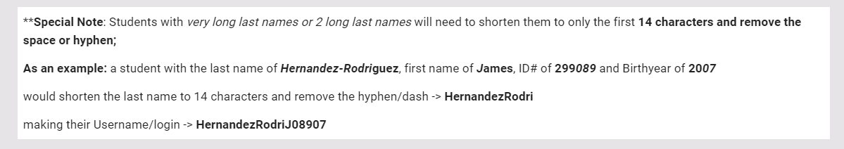

Classlink Single Sign-In Access Instructions
VVUHSD utilizes the Classlink portal for students to access much of the curriculum assigned by the district. Please follow the below directions to login to your Classlink portal. After successful login follow online instructions to customize the portal.
If using a personal device to access the Classlink portal, use the below link:
https://launchpad.classlink.com/vvstu

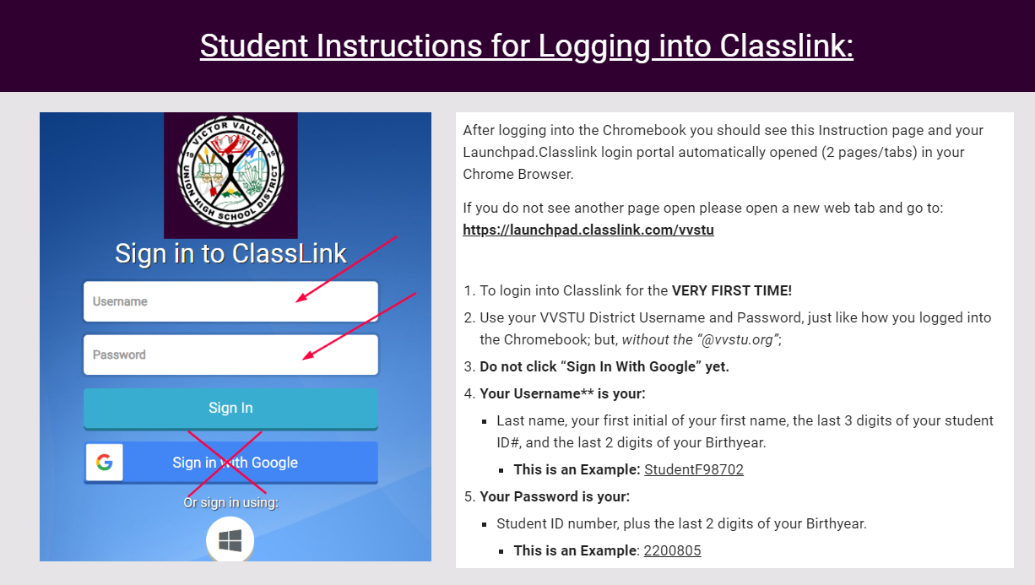

Once logged into Classlink use the online instructions to connect your Google account to your portal. Once your Google account is connected you may login with the Sign in with Google button for future logins.

Online Instructions - https://sites.google.com/vvuhsd.org/classlinkinstructions/home

